Testcase 1: **OFFLINE straight few days + Timezone**

Table: **D_PI_PRIMARY_PRESENCE_VW**

Query:

select PROJECTID, USERID, DURATION, ORGANIZATIONPRESENCE, PRESENCESTARTTIME, PRESENCEENDTIME, SYSTEMPRESENCE

from "PUREINSIGHTS_DEV"."PUBLIC"."D_PI_PRIMARY_PRESENCE_VW"

where PROJECTID = '701'

and USERID = '2d2558d3-54ab-4939-af84-b86c49b90801'

and ORGANIZATIONPRESENCE = 'Offline'

and PRESENCESTARTDATE = '2021-01-13';

Data:

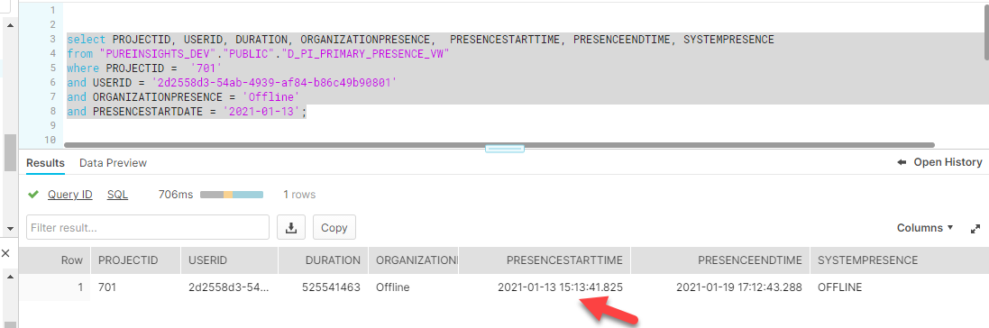

Table: **D_PI_PRIMARY_PRESENCE_DAILY_DURATION_VW**

Query:

select PROJECTID, USERID, DATE, DAILYPRESENCESTARTTIME, DAILYPRESENCESTARTTIME, SYSTEMPRESENCE, DAILYDURATION, TOTALDURATION

from "PUREINSIGHTS_DEV"."PUBLIC"."D_PI_PRIMARY_PRESENCE_DAILY_DURATION_VW"

where USERID = '2d2558d3-54ab-4939-af84-b86c49b90801'

and DATE >= '2021-01-13';

Data:

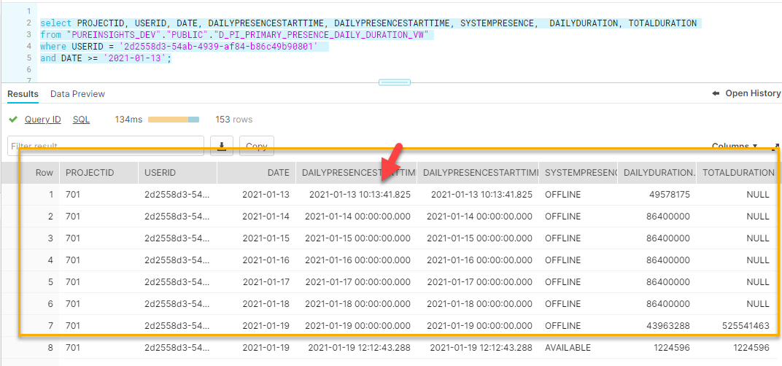

DAILYDURATION:

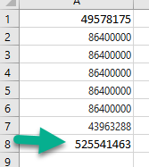

Testcase 2: **D_PI_PRIMARY_PRESENCE_VW go overnight (**two records in **D_PI_PRIMARY_PRESENCE_DAILY_DURATION_VW + timezone)**

**Note: Last IDLE activity goes through midnight from 2021-01-19 to 2021-01-20.**

Table: **D_PI_PRIMARY_PRESENCE_VW**

Query:

select PROJECTID, USERID, DURATION, ORGANIZATIONPRESENCE, PRESENCESTARTTIME, PRESENCEENDTIME, SYSTEMPRESENCE, PRESENCESTARTDATE,PRESENCEENDDATE

from "PUREINSIGHTS_DEV"."PUBLIC"."D_PI_PRIMARY_PRESENCE_VW"

where PROJECTID <> '741'

and USERID = '2d2558d3-54ab-4939-af84-b86c49b90801'

and PRESENCESTARTDATE >= '2021-01-19'

and PRESENCEENDDATE <= '2021-01-20';

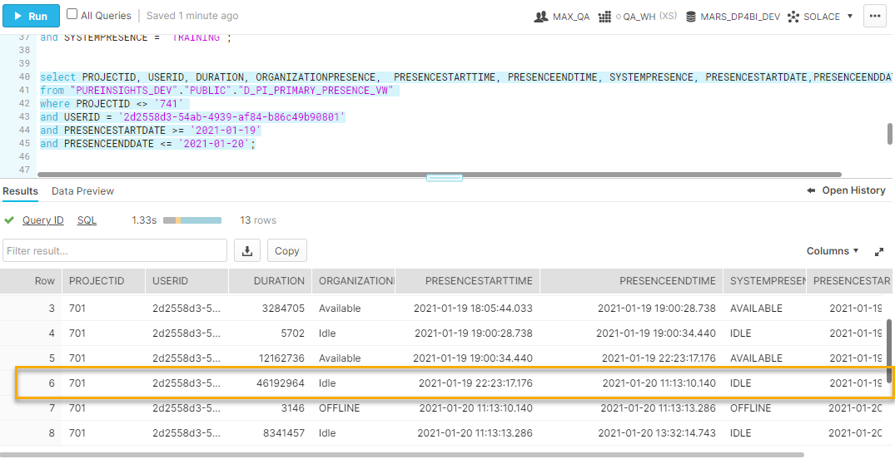

Table: **D_PI_PRIMARY_PRESENCE_DAILY_DURATION_VW**

Query:

select PROJECTID, USERID, DATE, DAILYPRESENCESTARTTIME, DAILYPRESENCEENDTIME, SYSTEMPRESENCE, DAILYDURATION, TOTALDURATION

from "PUREINSIGHTS_DEV"."PUBLIC"."D_PI_PRIMARY_PRESENCE_DAILY_DURATION_VW"

where USERID = '2d2558d3-54ab-4939-af84-b86c49b90801'

and Date >= '2021-01-19';

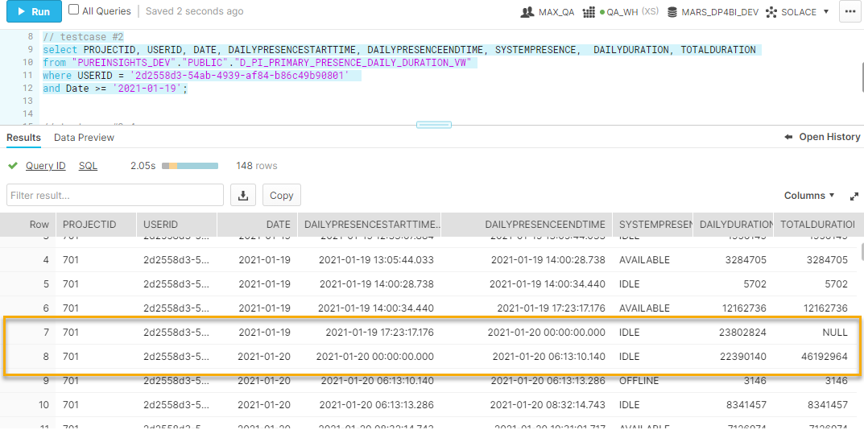

Testcase 3: **PRESENCESTARTTIME shift to another day because of timezone.**

**Note: IDLE**

Table: **D_PI_PRIMARY_PRESENCE_VW**

Query:

select PROJECTID, USERID, DURATION, ORGANIZATIONPRESENCE, PRESENCESTARTTIME, PRESENCEENDTIME, SYSTEMPRESENCE, PRESENCESTARTDATE,PRESENCEENDDATE

from "PUREINSIGHTS_DEV"."PUBLIC"."D_PI_PRIMARY_PRESENCE_VW"

where PROJECTID <> '741'

and USERID = '2d2558d3-54ab-4939-af84-b86c49b90801'

and PRESENCESTARTDATE >= '2021-01-22'

and PRESENCEENDDATE <= '2021-01-23';

Data:

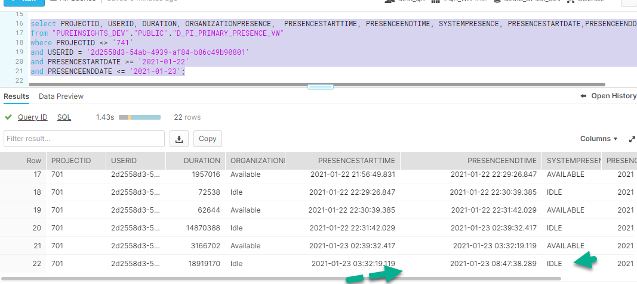

Table: **D_PI_PRIMARY_PRESENCE_DAILY_DURATION_VW**

Query:

select PROJECTID, USERID, DATE, DAILYPRESENCESTARTTIME, DAILYPRESENCEENDTIME, SYSTEMPRESENCE, DAILYDURATION, TOTALDURATION

from "PUREINSIGHTS_DEV"."PUBLIC"."D_PI_PRIMARY_PRESENCE_DAILY_DURATION_VW"

where USERID = '2d2558d3-54ab-4939-af84-b86c49b90801'

and Date >= '2021-01-22'

and Date <= '2021-01-23';

Data:

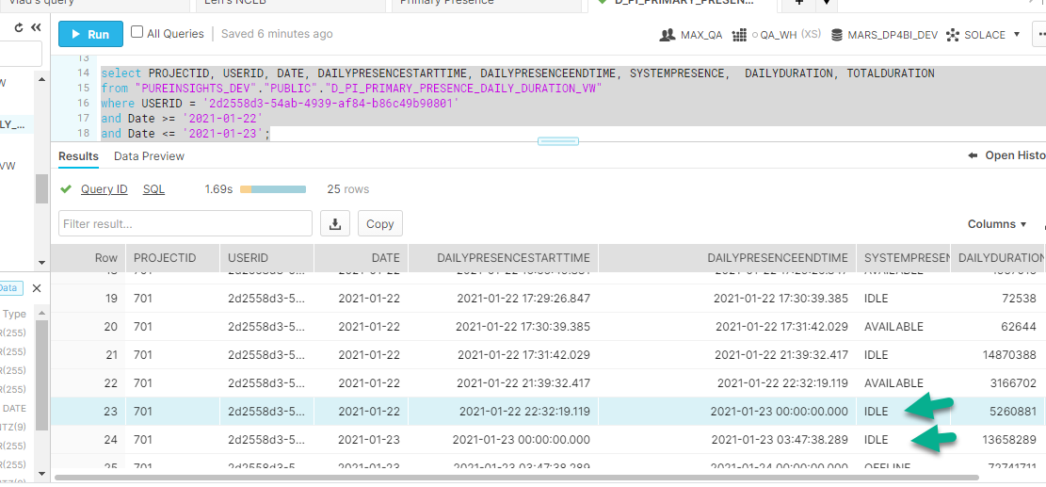

**Testcase 4:** One record of **D_PI_PRIMARY_PRESENCE_VW** (next day) represent two records (go overnight) in **D_PI_PRIMARY_PRESENCE_DAILY_DURATION_VW**

**Note: IDLE**

Table: **D_PI_PRIMARY_PRESENCE_VW**

Query:

select PROJECTID, USERID, DURATION, ORGANIZATIONPRESENCE, PRESENCESTARTTIME, PRESENCEENDTIME, SYSTEMPRESENCE, PRESENCESTARTDATE,PRESENCEENDDATE

from "PUREINSIGHTS_DEV"."PUBLIC"."D_PI_PRIMARY_PRESENCE_VW"

where PROJECTID <> '741'

and USERID = '2d2558d3-54ab-4939-af84-b86c49b90801'

and PRESENCESTARTDATE >= '2021-01-22'

and PRESENCEENDDATE <= '2021-01-23';

Data:

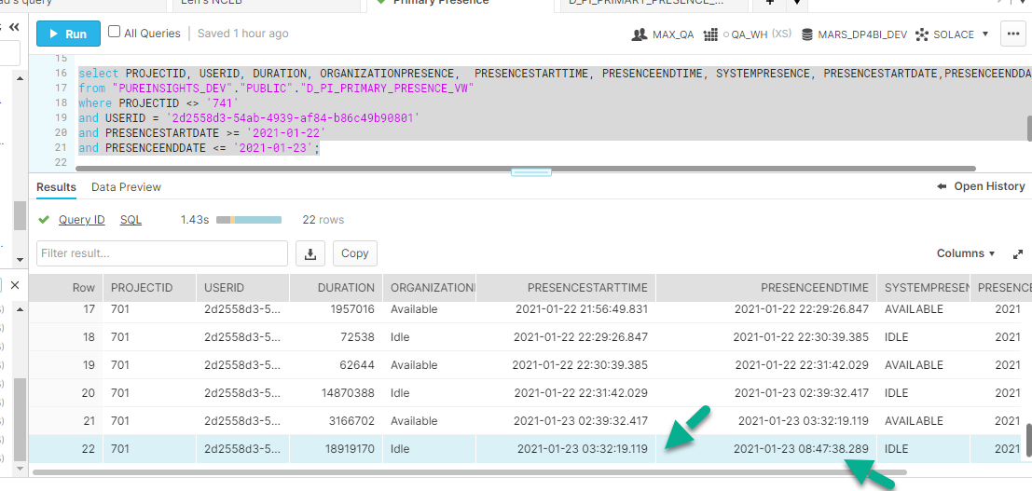

Table: **D_PI_PRIMARY_PRESENCE_DAILY_DURATION_VW**

Query:

select PROJECTID, USERID, DATE, DAILYPRESENCESTARTTIME, DAILYPRESENCEENDTIME, SYSTEMPRESENCE, DAILYDURATION, TOTALDURATION

from "PUREINSIGHTS_DEV"."PUBLIC"."D_PI_PRIMARY_PRESENCE_DAILY_DURATION_VW"

where USERID = '2d2558d3-54ab-4939-af84-b86c49b90801'

and Date >= '2021-01-22'

and Date <= '2021-01-23';

Data:

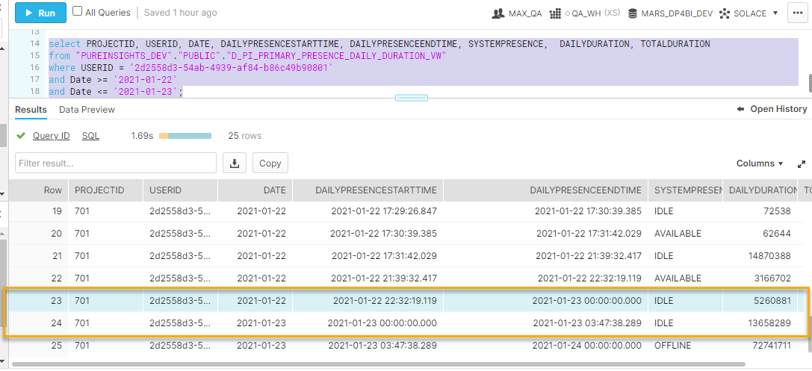

**Testcase 5:** One record of **D_PI_PRIMARY_PRESENCE_VW** (next day) represent one records in **D_PI_PRIMARY_PRESENCE_DAILY_DURATION_VW (different dates)**

**Note: IDLE**

Table: **D_PI_PRIMARY_PRESENCE_VW**

Query:

select PROJECTID, USERID, DURATION, ORGANIZATIONPRESENCE, PRESENCESTARTTIME, PRESENCEENDTIME, SYSTEMPRESENCE, PRESENCESTARTDATE,PRESENCEENDDATE

from "PUREINSIGHTS_DEV"."PUBLIC"."D_PI_PRIMARY_PRESENCE_VW"

where PROJECTID <> '741'

and USERID = 'ca6458e9-d02e-4520-8926-2e17457b79f3'

and SYSTEMPRESENCE = 'OFFLINE'

and PRESENCESTARTDATE >= '2021-01-20'

and PRESENCEENDDATE <= '2021-01-21';

Data:

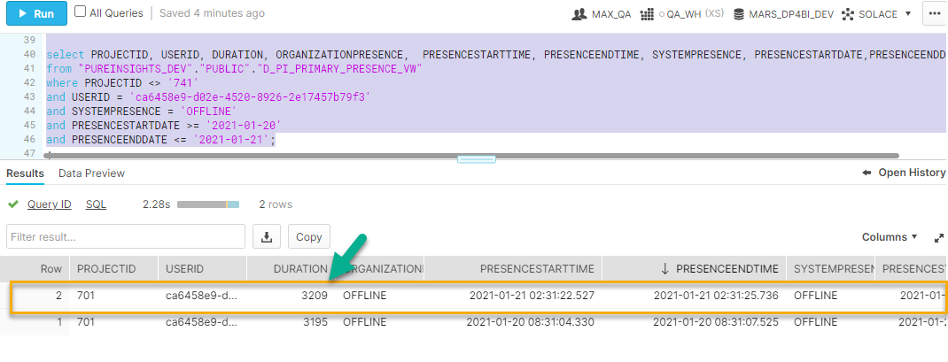

Table: **D_PI_PRIMARY_PRESENCE_DAILY_DURATION_VW**

Query:

select PROJECTID, USERID, DATE, DAILYPRESENCESTARTTIME, DAILYPRESENCEENDTIME, SYSTEMPRESENCE, DAILYDURATION, TOTALDURATION

from "PUREINSIGHTS_DEV"."PUBLIC"."D_PI_PRIMARY_PRESENCE_DAILY_DURATION_VW"

where USERID = 'ca6458e9-d02e-4520-8926-2e17457b79f3'

and SYSTEMPRESENCE = 'OFFLINE'

and Date = '2021-01-20';

Data:

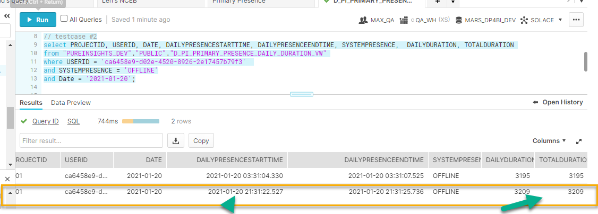

**Testcase 6:** The same **SYSTEMPRESENCE** but different **ORGANIZATIONPRESENCE**

**Note: IDLE**

Table: **D_PI_PRIMARY_PRESENCE_VW**

Query:

select PROJECTID, USERID, DURATION, ORGANIZATIONPRESENCE, PRESENCESTARTTIME, PRESENCEENDTIME, SYSTEMPRESENCE, PRESENCESTARTDATE,PRESENCEENDDATE

from "PUREINSIGHTS_DEV"."PUBLIC"."D_PI_PRIMARY_PRESENCE_VW"

where PROJECTID <> '741'

and USERID = 'ee59125c-7c4c-453b-a43f-7bcbb36ef790'

and PRESENCESTARTDATE >= '2021-02-03'

ORDER BY PRESENCESTARTTIME ASC;

Data:

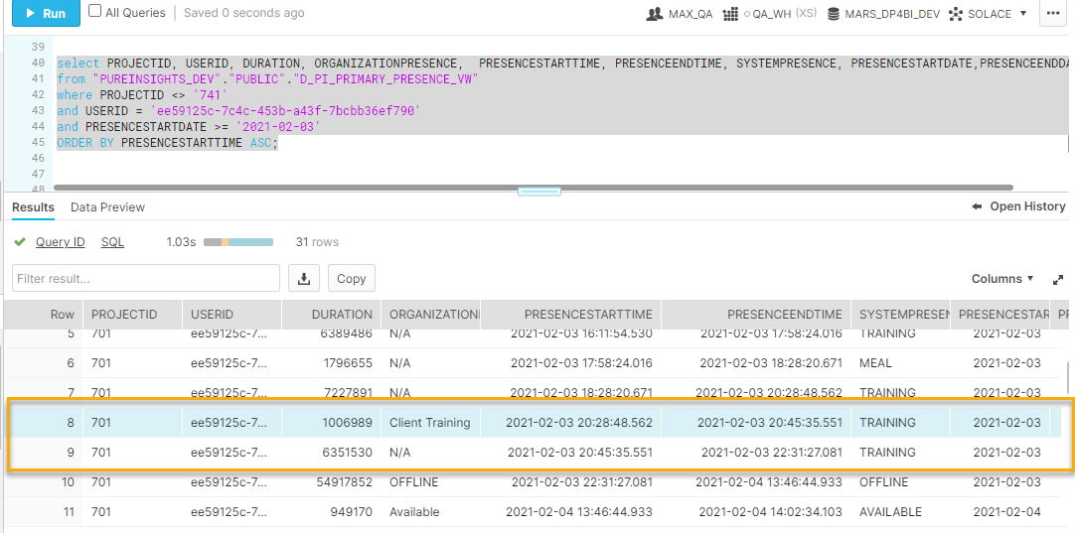

Table: **D_PI_PRIMARY_PRESENCE_DAILY_DURATION_VW**

Query:

select PROJECTID, USERID, DATE, DAILYPRESENCESTARTTIME, DAILYPRESENCEENDTIME, SYSTEMPRESENCE, ORGANIZATIONPRESENCE, DAILYDURATION, TOTALDURATION

from "PUREINSIGHTS_DEV"."PUBLIC"."D_PI_PRIMARY_PRESENCE_DAILY_DURATION_VW"

where USERID = 'ee59125c-7c4c-453b-a43f-7bcbb36ef790'

and SYSTEMPRESENCE = 'TRAINING';

Data:

